## 



Analysing Housing Prices In Metropolitan Areas Of India

V.Ananthraj

Team-6

Govt art's college men's nandanam chennai-35

**1 INTRODUCTION**

This project explains the Analysing Housing Prices In Metropolitan Areas Of India

**2 Problem Definition & Design Thinking**

2.1 Empathy Map

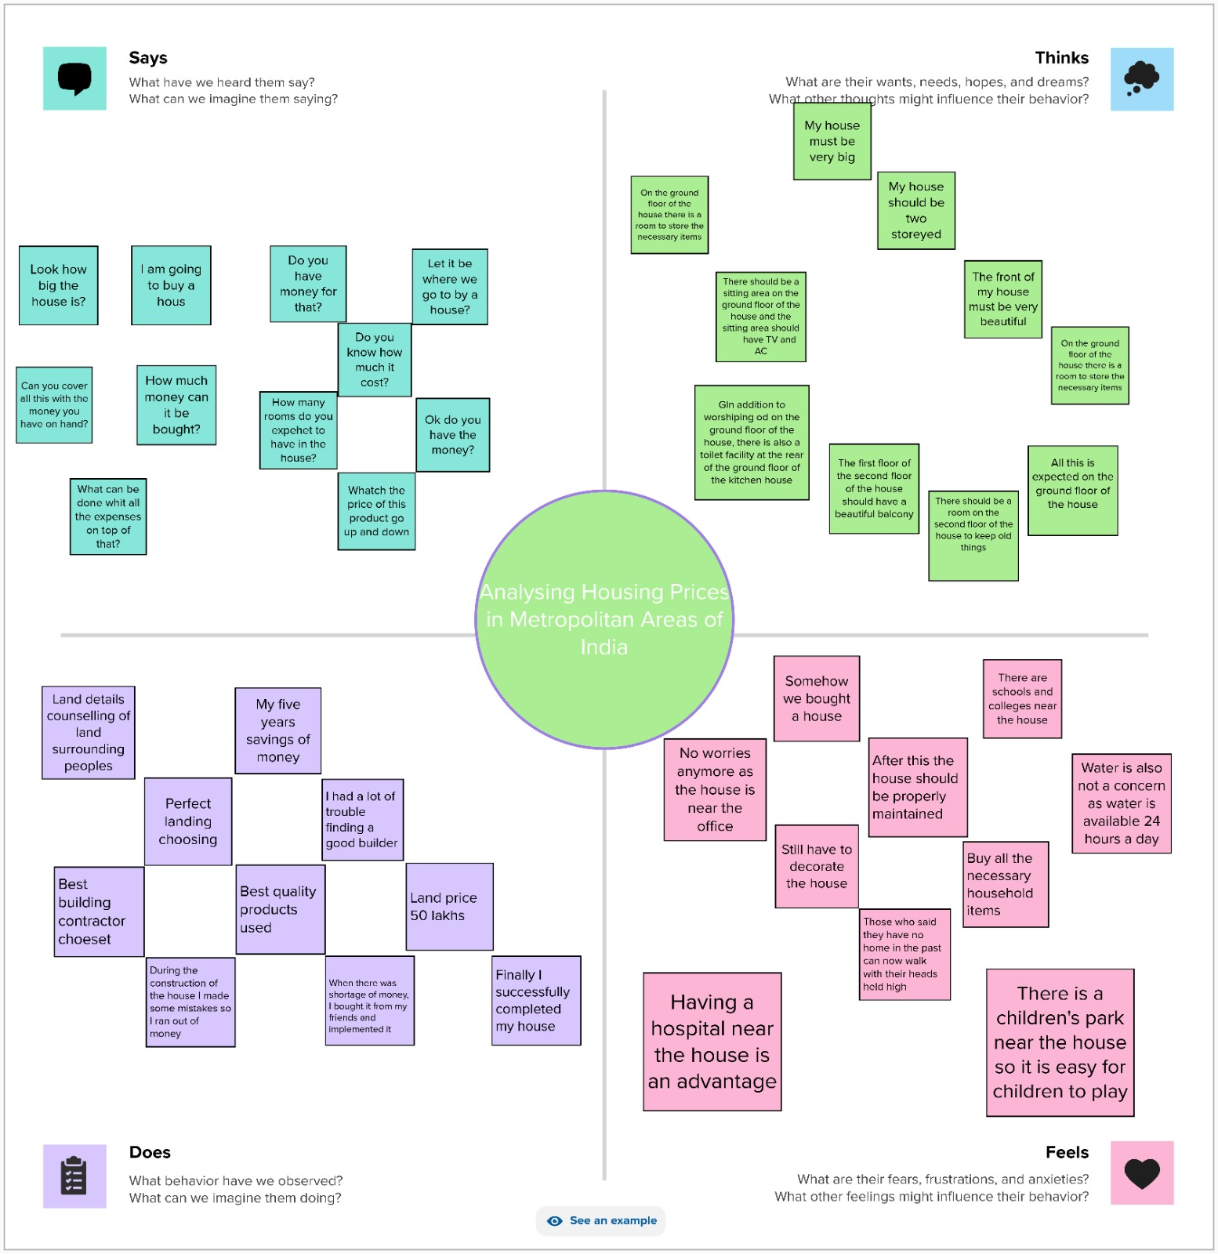

2.2 Ideation & Brainstorming Map

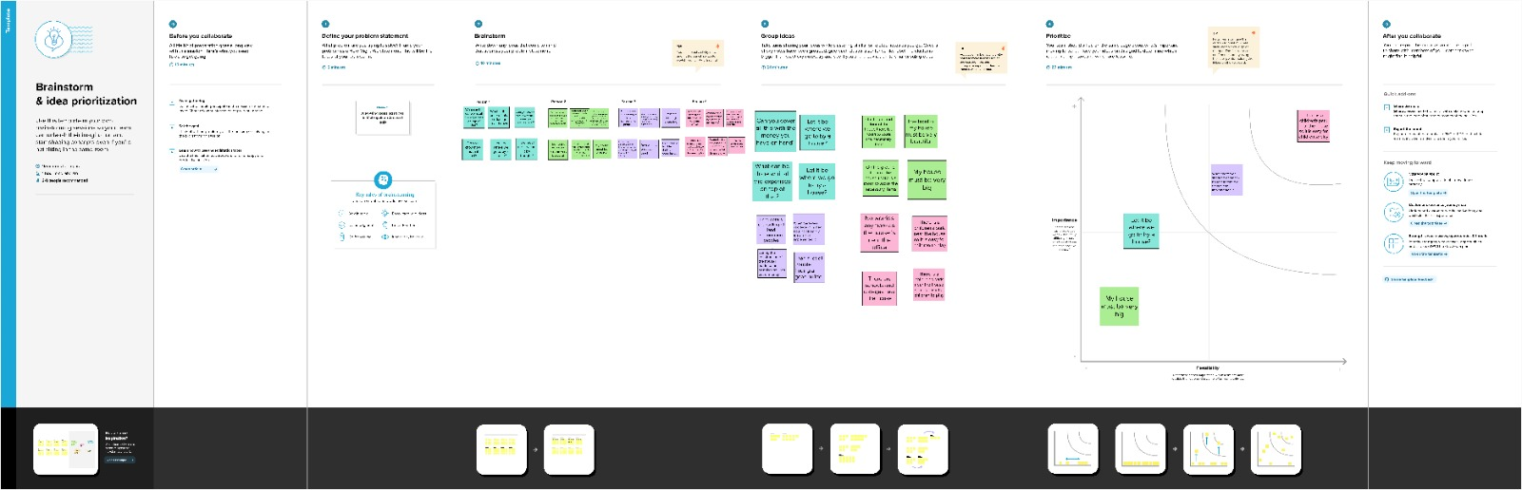

**3 RESULT**

Final findings (Output) of the project



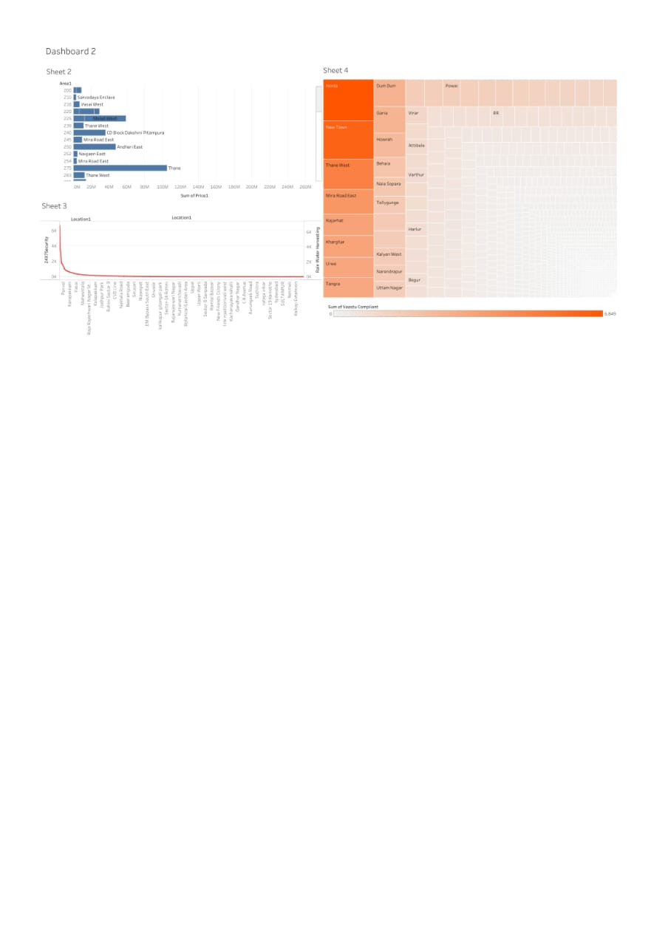

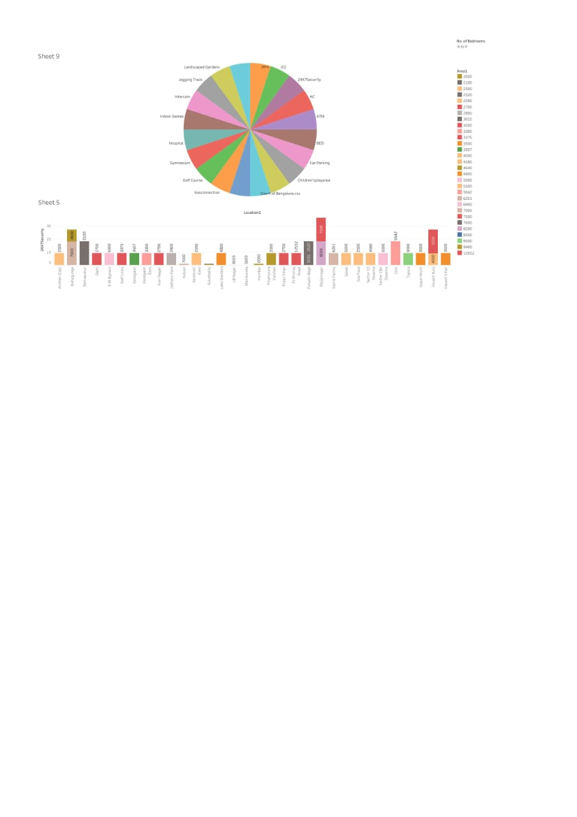

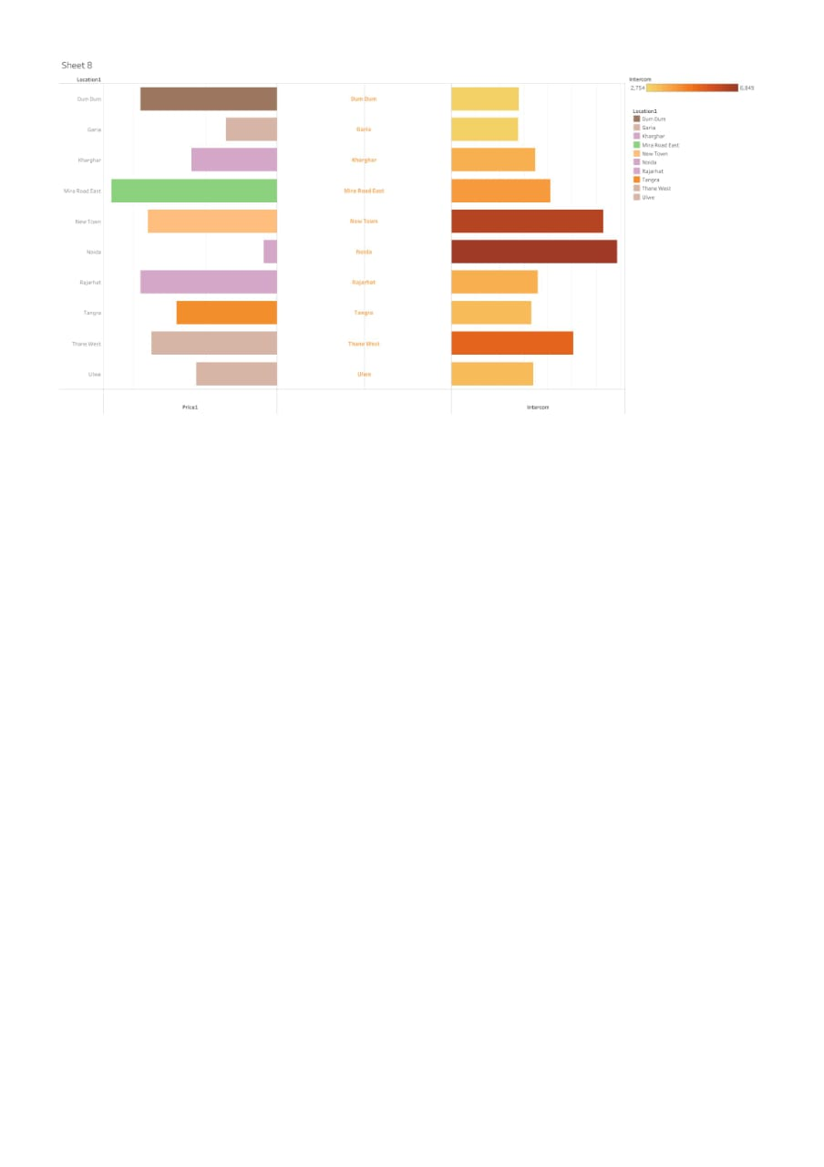

**4 ADVANTAGES & DISADVANTAGES**

ADVANTAGES:

House price prediction can help the developer determine the selling price of a house and can help the customer to arrange the right time to purchase a house.

There are three factors that influence the price of a house which include physical conditions, concept and location

Stability and peace of mind

DISADVANTAGES;

Must pay annual property taxes and homeowners' insurance (if you have a mortgage)

Comes with regular maintenance costs (for painting, mowing, edging, tree-trimming, plumbing, roof repairs, etc.)

5 **APPLICATION**

**House price prediction can help the developer determine the selling price of a house and can help the customer to arrange the right time to purchase a house. There are three factors that influence the price of a house which include physical conditions, concept and location**

6 **CONCLUSION**

Most of the previous analyses of house prices do not typically take into account these

three dimensions jointly so that the estimates produced are likely to be biased. The

conceptual model suggested in this paper will reflect temporal and spatial dimensions

in addition to the quality of a house represented by its intrinsic characteristics. The

estimates of the prospective model, therefore, are likely to be unbiased. This should

be seen as an alternative to the spatial panel or spatiotemporal house price models.

**7 FUTURE SCOPE**

**House price prediction can help the developer determine the selling price of a house and can help the customer to arrange the right time to purchase a house. There are three factors that influence the price of a house which include physical conditions, concept and location.**

**8 APPENDIXA**

Norwalk Multifamily Developments of 12 or More Units, Built and Occupied, 2000-2017

As of February 2018

Provided by the Norwalk Zoning Commission

Project Name Address Units Approval Date Built Year

AvalonBay Communities 24 Belden Avenue 312 3/19/2002 2010

80 Fair Street 80 Fair Street 59 7/18/2007 2010

Pepperidge Farms 597 Westport Avenue 235 7/29/2005 2010

Waterview East 142-144 East Avenue 36 2/15/2005 2010

130-134 Main Street LLC 130-134 Main Street 19 1/27/2006 2010

Summerview Place 2 Jefferson/West Main Street 41 7/19/2006 2013

Juliano Associates 42-46 Stuart Avenue 18 3/19/2007 2012

Point Rock at Oakwood 34 Oakwood Avenue 53 10/18/2013 2015

The Avrick 14-16 North Main Street 8 2/25/2011 2012

Avalon East Norwalk 8 Norden Place 240 11/27/2009 2013

Ironworks 20 North Water Street 108 2/24/2012 2014

The Waypointe 515 West Avenue 362 12/20/2013 2015

Teahouse Lofts 11 Merwin Street 98 11/25/2011 2015

Quincy Lofts 30 Orchard Street 69 5/30/2014 2017

The Berkeley 500-520 West Avenue 129 10/24/2014 2017

One Glover 1 Glover Avenue 132 2/28/2014 2015

Maritime Village 19 Day Street 57 10/24/2014 2017

Total Units 1,976